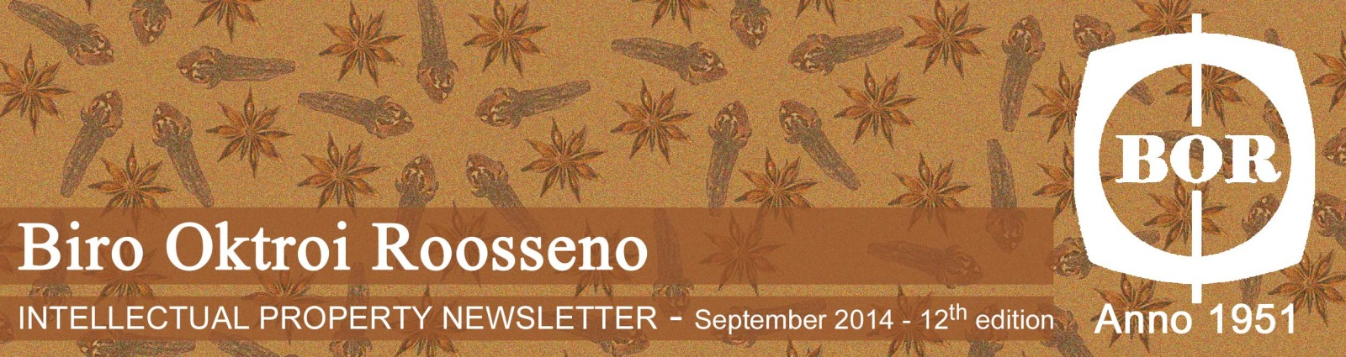
Biro Oktroi Roosseno
INTELLECTUAL PROPERTY NEWSLETTER – September 2018 – 28th Edition

This Edition Newsletter contains:
- New Regulation of the Ministry of Laws and Human Rights No.15 year 2018
- The Dispute for Paint Trademarks
- The Alternative Dispute Resolution (ADR) Training
- The Kinco Trademark Dispute
- Integrated Global Brand and Industrial Design Database in Southeast Asia's Countries
- PT. DEIN FOOD vs DIDIM Inc
- Ratification of the Beijing Treaty to Protect the Art Performers

1. New Regulation of the Ministry of Laws and Human Rights No.15 year 2018

Article 20 of the Patent Law No. 13 year 2016 stipulates that Patent holder is mandatory to implement the patent in Indonesia and such implementation should support the transfer of technology as well as the absorption of information and human resources. Based on the article 20 of the Patent Law No. 13 year 2016, the Government of Indonesia has stipulated a

new regulation of the Ministry of Laws and Human Rights No.15 year 2018 concerning the Implementation of Patent by the Patent holder which came into effect on July 11, 2018.

Under Article 2 of the Regulation of the Ministry of Laws and Human Rights No.15 year 2018, patent holder is mandatory to implement its patent in Indonesia. Moreover, article 3 of this Ministry Regulation stipulates that if a patent holder is still unable to implement its patent, the patent holder may request to the DGIP to postpone the implementation of its patent. This request should be submitted no later than 3 years from the granted date.
(source : BOR, dgip)

2. The Dispute for Paint Trademarks

Source: iStock

The intention of a South Korean paint manufacturer, Samhwa Paints Ind Co. Ltd., to cancel the existing Samhwa paint trademark in Indonesia failed when the Central Jakarta Commercial Court rejected their lawsuit. The Court dismissed the suit due to the Plaintiff’s argument of their mark being a well-known was not accepted, even though they have registered their trademark in other countries. In the court's view, for the local consumer, it is considered not as a well-known mark.

With this court decision, Samhwa Paints Ind Co. Ltd. intends to file a cassation to the Supreme Court after obtaining a copy of the official ruling from the Central Jakarta District Court. This case started when the plaintiff filed a trademark application in Indonesia on January 4, 2018, under the application number DID2018000506.

However, an identical trademark belonging to the defendant hampered the application.
On November 2011, the plaintiff and the defendant had a business meeting in a visit to the defendant's factory. After one month, the defendant registered the Samhwa trademark to the Directorate of Trademarks, Directorate General of Intellectual Property (DGIP). The defendant registered The Samhwa trademark on December 19, 2011, with registration number IDM000417588. It The registered trademark is in class 2 which includes wall paint, wooden paint and car paint.

Based on these conditions, Samhwa Paints Ind Co. Ltd. filed a lawsuit against the owner of a paint factory in Indonesia, PT Futanlux Chemitraco, named Henry Chandra Tjo. The Plaintiff did not accept the action of the defendant who imitated, plagiarised, and made use of the plaintiff's trademark fame.
On the other hand, the owner of PT Futanlux Chemitraco Henry Chandra Tjo denied the allegation of copying the Samhwa paint brand that was filed by Samhwa Paints Co. Ltd.
Henry Chandra Tjo's attorney revealed that Indonesia regulates the principle of first to file or the first registered trademark owner, per Article 1 Paragraph (5) of Law No.20 / 2016 concerning Trademarks, this means that if a conflict or dispute arises in regard to ownership, the first registrant is considered the rights owner.

If there are opponents who object to the registration of the trademark, they can raise objections within 14 days. However, Samhwa Paints Ind. Co. Ltd did not do so. Moreover, Henry Chandra Tjo promoted his Samhwa Trademark in Indonesia until the Indonesian people well received it.
(source : http://sipp.pn-jakartapusat.go.id)

3. The Alternative Dispute Resolution (ADR) Training

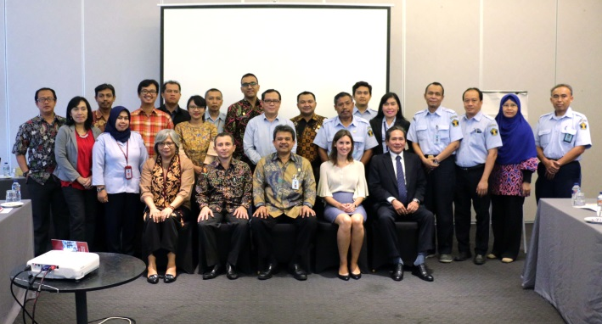

The Directorate General of Intellectual Property (DJKI), Ministry of Law and Human Rights in collaboration with the Swiss Secretariat for Economic Affairs (SECO) within the framework of the Indonesia-Swiss Intellectual Property (ISIP) Project Phase II held an Alternative Dispute Resolution (ADR) workshop for seven days at the Park 5 Hotel (www.dgip.go.id, 3/9/2018).

Participants from Directorate general Intellectual Property (DGIP), the representatives of the Swiss Federal Institute of Intellectual Property and the Executive Director of the National Mediation Center, Mr. A. Fahmi Shahab all attended the event.
The Director of Trademarks and Geographical Indications of the DGIP, Mr Fathlurrachman, officially opened the event and expressed his highest appreciation to all the parties, i.e. National Mediation Center, DGIP and especially to the Swiss Government through SECO. With this event, hopefully, more parties can utilise ADR as one of the best ways to resolve IP disputes.

An Intellectual Property Dispute arises when a party infringes an exclusive right of another party through the utilisation of the exclusive right against the law and / or without the consent of the owner.

Most importantly the law must be able to protect the creators of intellectual property works and the owners of these respective rights, according to Mr Fathlurachman in his opening remarks. He continued that basically, parties can achieve the resolution of Intellectual Property Disputes through litigation or non-litigation ways, this includes Alternative Dispute Resolution (ADR). "The resolution of an Intellectual Property Disputes through a non-litigation path or mediation institutions should be considered as the best solution since it is faster and more cost-effective compared to resolved through litigation, " said Fathlurachman.

Several actions for the Intellectual Property law enforcement is carried out by the law enforcement officers, including the Intellectual Property investigators. The DGIP established the Directorate of Investigation, and Dispute Resolution at the DGIP in 2010, this is a concrete action of law enforcement in the Intellectual Property field. Most importantly, the IP owners can resolve their IP dispute amicably without having to go through a more drawn out litigation.
(source: dgip.go.id)

4. The Kinco Trademark Dispute

Kinco Group Company Limited is a refrigeration equipment manufacturer, established in 1979 and has its well-developed home base in Taiwan for the last 30 years.

Currently, Kinco has accumulated a list of major overseas markets throughout the USA, Australia, New Zealand, Oceania, Philippines, Vietnam, Singapore, Indonesia, Hong Kong and Malaysia, among others.

When Kinco Group Company Limited filed their well-known mark in Indonesia, they encountered a problem whereas a local Indonesian company has already registered the mark KINCO in Indonesia. A local party had registered The Kinco trademark at the Directorate of Trademarks, Directorate General of Intellectual Property with agenda No. IDM000619419 on behalf of PT. Holicindo Dasa Anugerah. The registeration is in class 7 which protects food machinery and refrigerators for food displays.

Pursuant to this matter, the Kinco Group Company Limited filed a lawsuit against the said local Indonesian company in the Commercial Court of Central Jakarta on July 30th, 2108 under the registration number 38/Pdt.Sus HKI/Merek/2018/PN Niaga Jkt.Pst. Currently, the case is still pending for examinations, and court hearings are still being held.

The plaintiff stated that they had been the owners of the KINCO mark and Logo since 1984 and the Kinco Logo Brand since 1986. They noted that the KINCO mark and logo on behalf of the defendant has similarities in essential part with the plaintiff's mark and Logo.

The plaintiff asked the court to declare that the KINCO trademarks and registered Logos No. IDM000619419 on behalf of PT. Holicindo Dasa Anugerah has been registered with bad faith. The plaintiff also requested the cancellation of the KINCO trademarks and registered Logos brand with the number IDM000619419.
(source : http://sipp.pn-jakartapusat.go.id)

5. Integrated Global Brand and Industrial Design Database in Southeast Asia's Countries

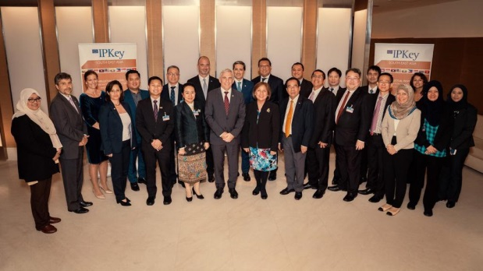

There are three Intellectual Property Offices which database will be integrated for trademark and design into the global trademark search and design database, namely TMview and Designview. The said Intellectual Property Offices are Indonesia, Brunei Darussalam and Laos. The databases have been developed by the European Union Intellectual Property Office (EUIPO), together with their European and International partners.

In Geneva, some Director Generals and senior officials from many Intellectual Property Offices in Southeast Asia having discussion with the representatives from EUIPO with their goals to deliver the state of the art of database for the Intellectual Property Offices in Southeast Asia. This is regulated in the framework of the IP Key SEA program which funded by the European Union.

The Indonesian Director General of Intellectual Property, Mr. Freddy Harris, explained that the additional data from Indonesia will be consolidated for further-use of the TMview and Designview databases. The database can be used as resources for intellectual property right holders and intellectual property practitioners explained Mr. Freddy Harris.

For further information, TMview currently contains more than 50 million trademarks from 67 intellectual property offices worldwide, while Designview shall contains around 14 million designs from 67 participating intellectual property offices.
Both of these databases can be use for free, easily accessible and available 24 hour non-stop. Users can search for any trademarks or designs on each list of brands and industrial designs from the participating intellectual property offices.

The (task executor) European Union Intellectual Property Office Executive Director, Mr. Christian Archambeau, explained that this meeting is a continuation of the EU's commitment to supporting our partners in Southeast Asia, in building services and protecting stronger intellectual property.
(source: dgip.go.id)

6. PT. DEIN FOOD vs DIDIM Inc.

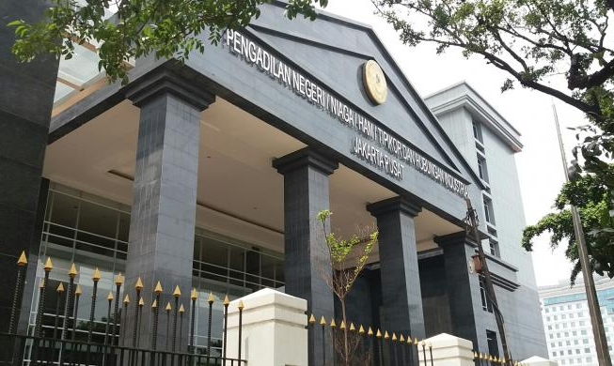

Korean restaurant company, DIDIM Inc, filed a cancellation lawsuit for the MAGAL trademark belonging to the local company, PT. Dien Food, in Central Jakarta Commercial Court on August 16th, 2108 under the registration number 43/Pdt.Sus-HKI/Merek/2018/PN Niaga Jkt.Pst. DIDIM Inc. is a company whose line of business is an advanced country type eating out business since April 1999. It started from a small rib house which then developed into a Large DM restaurant business, franchise livestock processing, food manufacturing and distribution.

The plaintiff stated that the MAGAL trademark registered under Registration No. IDM000616294, IDM000607205, and IDM000607528 on behalf of PT. Dien Food was filed based on bad faith and is contrary to Article 21 of the Republic of Indonesia Law Number 20 of 2016 concerning Trademarks and Geographical Indications.

The plaintiff also requested to grant the Registration Application of the MAGAL trademark on behalf of DIDIM Inc. They also claimed to have exclusive rights of the MAGAL trademark for the types of goods/services in class 43 which protects all kinds of services in providing food and beverages (restaurants, cafes, depots, stalls, shops, cafeterias, bars, canteens, food courts, restaurants, self-service restaurants etc).

Currently, this case is still at the early court examination stages and awaiting the verdict of the court.
(Source: Nasional Kompas)

7. Ratification of the Beijing Treaty to Protect the Art Performers

On September 2018, Indonesia attended the General Session of the World Intellectual Property Organization in Geneva, Switzerland. The representatives from Indonesia are the Minister of Law and Human Rights, Mr. Yasonna H Laoly, the Inspector General of the Ministry of Law and Human Rights, Mr. Aidir Amin Daud, the Director General of Intellectual Property, Mr. Freddy Harris along with his staffs.

In this General Session, Mr. Yasonna discussed about copyrights, protection of Audio-Visual performers, and Geographical Indications, as well as Genetic Resources, Traditional Knowledge, and the Expressions of Traditional Culture. Mr. Yasonna conveyed during his speech that with regard to the copyright, Indonesia has adopted the provisions of the Marrakesh Treaty and the Beijing Treaty in Copyright Law No. 28 of 2014.
According to the Minister of Law and Human Rights, Mr. Yasonna, The Beijing Treaty is important for Indonesia to be ratified, because it provides protection for artists or art performers, who perform their audio-visual creations, which is an important element in the development of the national creativity. This will contribute significantly to increase the growth of the economy creative. At the end, it will also contribute to the economic development and people's welfare.

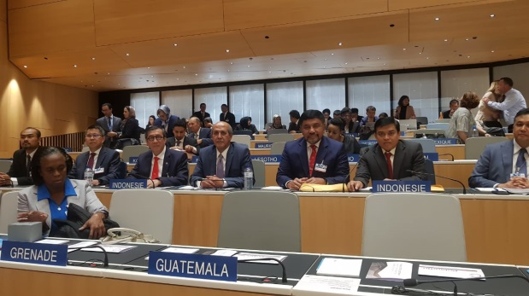

Furthermore, Mr. Yasonna explained that the Beijing Treaty would provide legal certainty for the moral rights and economic rights for the art performers, especially to protect the performance of performances in the digital era. "Therefore, Indonesia has adopted the provisions of Beijing Treaty in the Article 22 and 23 of the Copyright Law. The ratification of the Beijing Treaty is one of Indonesia's commitments to adjust to the global development of Copyright.

With these rulings, art performers have the authority to give permission or prohibit other parties from broadcasting or making fixations from the actors of their audio-visual performances. In this case, by ratification of the Beijing Treaty, will also have a positive impact on the application of the right to reproduce a music into other media or commonly called mechanical rights and royalty systems. The copyright protection not only intended to audio shows, but also protects audio-visual performances.

In addition, Mr. Yasonna also stated that Indonesia is currently building registration and database on the Genetic Resources, Traditional Knowledge, and the Expressions of Traditional Culture and he also conveys that Indonesia has recently adopted regulations that discuss mechanisms for access and distribution of benefits from genetic resources.

Mr. Yasonna really hopes that through the WIPO general session, the Intergovernmental Committee on the Intellectual Property and Genetic Resources, Traditional Knowledge and Folklore (IGC) can accelerate its task in producing international legal instruments on protecting SDGPTEBT.
(source: dgip.go.id)

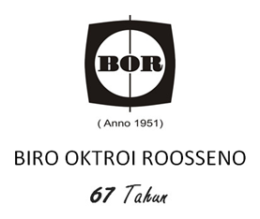
Phone No. : (62-21) 576 2310 (Hunting System)
Fax. No. :(62-21) 576 2301, (62-21) 576 2302,
eFax. No. : (65) 6826 4084
E-mail : iprlaw@iprbor.com
Website : www.iprbor.com

Kantor Taman A9, Unit C1 & C2
Jl. Dr. Ide Anak Agung Gde Agung (Mega Kuningan),
Jakarta 12950, Indonesia
P.O. Box 4585, Jakarta 10001

